Mid Sweden University
The Department of Information Technology and Media (ITM)
Author: Fengjiao Lv
E-mail address: felv1100@student.miun.se
Study programme: Web services, 7.5credits
Examiner:
Tutors: [Bertil Bertilsson, organisation X, e-mail address]
Scope: 0 words inclusive of appendices
Date: 2012-03-18

[Place for illustration]
B.Sc. project report
within Computer Engineering Engineering C, course, 7.5 points]

Transaction Chain Simulation
web services project

Fengjiao Lv

Abstract
The goal of the project is to simulate transaction between customers and warehouse using SOAP web services. In every transaction, item price should change according to some mathematical law.
The main implement is to create two XML files. One contains the history of every transaction, the other is current price. The survey has been conducted with the aid of DOM. The DOM presents an XML document as a tree-structure. It will be talked more in the report.
The survey has been conducted with the aid of SOAP web services and Client-server model. Service will provide method, client will call the method and return data to service and make change to service’s constructor. A temporary document called “temp.txt” is created.
The structure of my project is described briefly in this part and will talk more in the report. Server provide functions to display current price in XML , buy items and read new price from “temp.txt” after every communication ,while Client can call these functions and buy item randomly. Any customer has access to get the price and buy items.
In my project, XSL/T and XML is also implemented, transformed XML to HTML by using XSLT, and all are well-formed.
Keywords: Client-server model, XML, DOM, XSL/T, JAX-WS.

Foreword
The project is to simulate complex transaction between two actors with the use of SOAP web service. Different actors have different functions in this project with the changing price. It will be implemented with web services. More detailed knowledge is studies through the project, such as the advantages and disadvantages of Web Services and how to save what has been done. Web services should be altered to meet identified needs.
To complete the project, some foundation knowledge is referred from some books and some learned online. A lot of mistakes are corrected with the aid of classmates and teachers.

Table of Contents
Abstract ii
Foreword iii
Terminology vi
1 Introduction 1
2 XML DOM Introduction 5
3 Customer-Warehouse Model 9
4 Design 11
4.1.1 Client-server model 11
4.1.2 Warehouse 11
4.1.3 Customer 13
5 Results 15
6 Discussion 21
References 22

Terminology

Acronyms / Abbreviations
XML Extensible Mark-up Language. Define a set of rules for encoding documents and the basis for Web services
SOAP Simple Object Access Protocol.
UDDI Universal Description, Discovery and Integration.
WSDL Web Services Description Language.
DOM Document Object Model. Defines a standard way for accessing and manipulating XML documents.
XSL/T Extensible Stylesheet Language Transformations. Transform XML documents into other formats

- Introduction
Business is increasingly moving from transactional-based business processes to a service oriented approach, often involving collaboration of multiple organizations to provide an integrated service to customers. The Client-server model using web services should be used to make life more convenient.
The goal of this project is to simulate complex transaction between customer and warehouse. The price is updated in every purchase. Warehouse acts as the server to update and show price. Customer acts as client to purchase items and transfer the buying information to server. With the aid of SOAP web services, more customers in different java application can buy items separately, sharing and updating the price of items independently.
In project, XML is used to store information about products and transaction (“logs”).XSL/T is used to transform the transaction data (“logs”) for presentation.

Background and problem motivation
1. About the technology
Web services: Business is increasingly moving from transactional-based business processes to a service oriented approach, often involving collaboration of multiple organizations to provide an integrated service to customers. Additionally, the current economic downtown means there is increasing pressure to consolidate information systems and capitalize on existing investment ^{[2]}. An effective way of reusing components and integrating services is essential, both within business-to-business and client-to-business applications and services, and internally within businesses themselves.
In this case, web Services have two types of uses: reusable application-components and connect existing software, which be applied without doubt.
DOM: XML support in programming languages, DOM, JDOM (java-based document object model for XML) and SAX, all have some benefits and weakness, and simplify programming.
2. About the problem motivation
The problem is related to transact items in real life closely. The project has an important role in digital life, commercialization and date sharing.
We can compare the original project and individual one. Same parts: the project is to simulate complex transaction between actors with the use of SOAP web service. Runtime calculations of pricing should be done throughout all the simulation. Different parts: individual one is that some of the actors will produce services and others will consume them; the original one is that some of the actors will produce services and other will consume them, decisions on how to react should be based on product pricing, trends, and availability of products.

Overall aim
The goal of this project is to simulate complex transactions between two actors with the use of SOAP web services. Some of the actors will produce services and others will consume them. Runtime calculations of pricing should be done throughout all the simulation with every transaction.
The project’s overall aim is to implement Client-server model using web application and process XML with DOM tree. For the purpose, the survey is centred on SOAP web services and DOM.

Scope
The study has its focus on web application using Netbeans 7.0.1 and Glassfish, so learning clients and servers is important. In the project, the number of items is ignored, because we focus on the implement of the web application not the number.

Concrete and verifiable goals
The different parts of this project are:
2 x Java applications called Customers (Web Service Clients) and
1 x Web application called Warehouse (Web Service)
Warehouse
The main task of the warehouse is to sell merchandises to customers. The warehouse should have 5 different pcs of equipment possible to buy. New prices on every item should be set with every transaction.
Rules for business:
- A customer has the possibility to buy items from the warehouses.
- The number of items in the warehouse is 5 different pcs with different initial price and the stock of them are infinite.
- The initial price of the items, numbered 0-4, in stock should be 50, 100, 150 , 200 and 250 project dollars.
- Every time one item is sold the sell price of it should increase with 5% and the sell price for all other items not sold should be lowered by 2%.
- Every transaction made by the warehouse should be ”logged” in the warehouse so that it will be possible to see the transaction history with buyer information, item sold and current prices on all the items.
- Two web services have to be created to fulfil the demands for the String getPrices()
▪ Returns an XML string with all the items and prices
int buyItem(int itemNo)
▪ Returns an integer telling the price of the item bought or -1 on error. The variable itemNo is the item to buy.
Customer
The customer strategy rules are as follows.
- The customer have a total budget of 5000 project dollars each that will be reduced buy the price of the item in every transaction made.
- The item to buy in every transaction could be randomly generated or chosen by some kind of strategy of your choice.
- To be able to buy one item the customer have to check the price before buying it to see that there is project dollars left to make the transaction. If the amount of money isn't enough the customer can close its actions and end execution.
- Every transaction made should be”logged” so that it will be possible to see the transaction history and the price for the items bought.
Implementation of the different parts
- XML should be used to store information about products and transactions (”logs”).
- XSL/T should be used to transform the transaction data (”logs”) for presentation.

Outline
Chapter 2 describes XML DOM Introduction.
Chapter 3 describes Warehouse-Customer model.
Chapter 4 describes design of the project.
Chapter 5 describes results of the website

Contributions
The project and the report are done all by myself. Meanwhile search some resources from the Internet and books.
Processing XML using DOM is learned from JAVA XML on http://webct6.miun.se.
- XML DOM Introduction
In this part, the report focuses on how to create and update XML file.
XML DOM:
Definition: The W3C Document Object Model (DOM) is a platform and language-neutral interface that allows programs and scripts to dynamically access and update the content, structure, and style of a document.^{[3].}
Summary: The XML DOM is:
1) A standard object model for XML
2) A standard programming interface for XML
3) Platform- and language-independent
4) A W3C standard
The DOM defines the objects and properties of all document elements, and the methods (interface) to access them.
In other words: The XML DOM is a standard for how to get, change, add, or delete XML elements.
The aim of using XML DOM in my project is to establish DOM tree to create and update XML file.

Definition of terms and abbreviations
- DOM node: everything in an XML document is a node.
The DOM says:
- The entire document is a document node
- Every XML element is an element node
- The text in the XML elements are text nodes
- Every attribute is an attribute node
- Comments are comment nodes

- DOM node tree: The node tree shows the set of nodes, and the connections between them. The tree starts at the root node and branches out to the text nodes at the lowest level of the tree
- DOM method: The programming interface to the DOM is defined by a set standard properties and methods
Eg:Example of XML DOM method
- getElementsByTagName("title")[0] - the first <title> element
- childNodes[0] - the first child of the <title> element (the text node)
- nodeValue - the value of the node (the text itself)

Example:
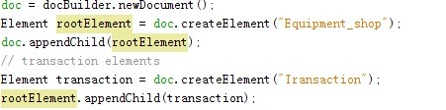
And XML display as followed:
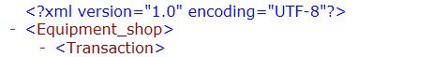

The XML DOM tree in my project
(1) Log.xml used to store the history of transaction.
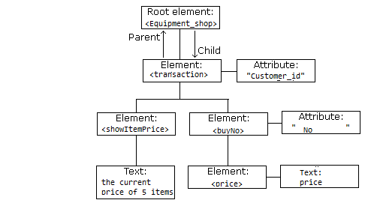
(2) current price.xml. Used to store current price of warehouse.
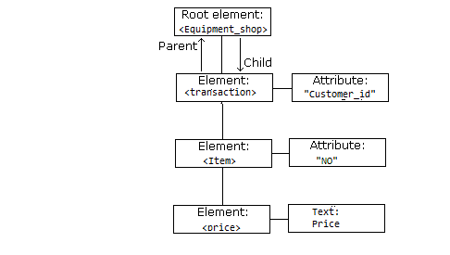

Code implement: Establish DOM and Put the XML DOM into XML file
Take current_price.xml as example:
1. Establish DOM:
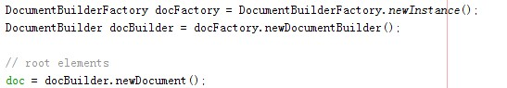
doc is the DOM document which docbuilder create.
2. Put the XML DOM into XML file
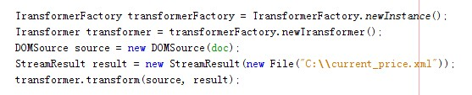

- Customer-Warehouse Model
In this part, we focus on the logical structure of the project.
Supported technology:
Java API for XML Web Services (JAX-WS), JSR 224^{[1]}
After you create the web service, you can write three different web service clients that use the web service over a network, which is called "consuming" a web service. The three clients are a Java class in a Java SE application, a servlet, and a JSP page in a web application.
In the project. We choose Java SE application
Client-server model
Using JAX-WS web services, when calling the web method, new web service is called. That means the constructor of the web services is called again.
In my project, a new document (”C://temp.txt”) is created. The document is to save current price and the constructor of webserver reads new price from the document.
Warehouse:
- A customer has the possibility to buy items from the warehouses.
- The number of items in the warehouse is 5 different pcs with different initial price and the stock of them are infinite.
- The initial price of the items, numbered 0-4, in stock should be 50, 100, 150, 200 and 250 project dollars.
- Every time one item is sold the sell price of it should increase with 5% and the sell price for all other items not sold should be lowered by 2%.
- Every transaction made by the warehouse should be ”logged” in the warehouse so that it will be possible to see the transaction history with buyer information, item sold and current prices on all the items.
Customer:
- The customer have a total budget of 5000 project dollars each that will be reduced buy the price of the item in every transaction made.
- The item to buy in every transaction could be randomly generated or chosen by some kind of strategy of your choice.
- To be able to buy one item the customer have to check the price before buying it to see that there is project dollars left to make the transaction. If the amount of money isn't enough the customer can close its actions and end execution.
- Every transaction made should be ”logged” so that it will be possible to see the transaction history and the price for the items bought
The structure is as followed.
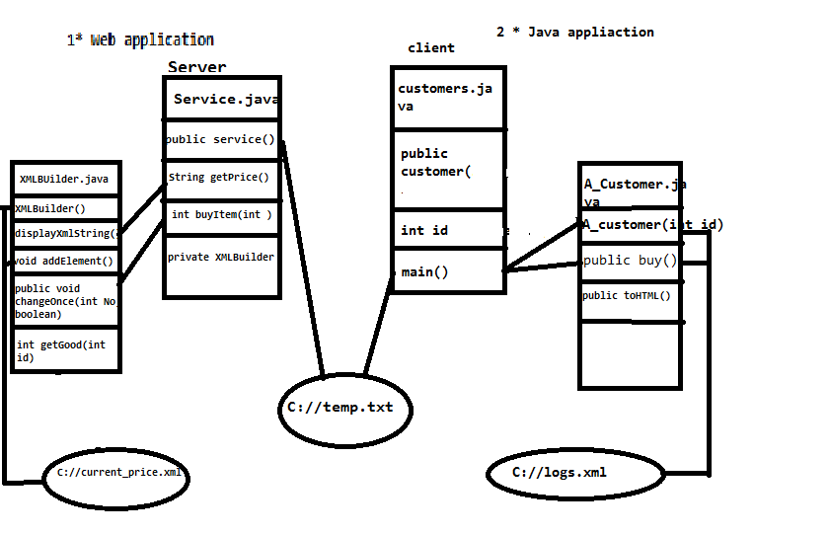
- Design

Logical structure

Client-server model
Using JAX-WS web services, when calling the web method, new web service is called. That means the constructor of the web services is called again.
Question: In my project, the prices have changed after one purchase. How to save updated price?
In my project, a new document (”C://temp.txt”) is created. The document is to save current price and the constructor of webserver read new price from the document.
We can explain it through the figure:
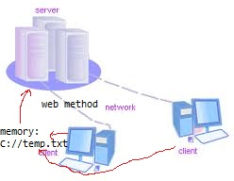

Warehouse
Suppose: the original price of items is 50,100,150,200,250
Before running,”C://temp.txt” must be created for the reason talked above. C://logs.xsl and C://current_price.xsl must be done and put the right position.
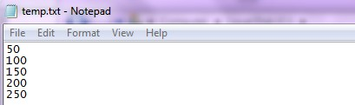

The function of warehouse:
- String getPrice():Returns an XML string with all the items and current prices.
- Int buyItem(int ItemNo) : Returns an integer telling the price of the item bought or -1 on error. The variable itemNo is the item to buy.
There are two .java in warehouse source package
- Service.java:
- public Service();
function: Instancing xmlBuilder.
- @WebMethod(operationName = "getPrice")
public String getPrice();
function: call xmlBulider.displayXMLString(),Returns an XML string with all the items and current prices.
- @WebMethod(operationName = "buyItem")
public int buyItem(@WebParam(name = "itemNo") int itemNo);
function: call xmlBuilder. changeOnce().Returns an integer telling the price of the item bought or -1 on error. The variable itemNo is the item to buy.
- xmlBuilder.java
- private Map<Integer, Integer> goodmap;
store the current price of every item.
- public XMLBuilder();
function: create or empty the xml, and write updated price into the XML. Updated price is from “C://temp.txt”
- public void changeOnce(int No, boolean b);
argument:No is the item the Customer want to buy.
function: changing the price. Every time one item is sold the sell price of it should increase with 5% and the sell price for all other items not sold should be lowered by 2%. And write the changed price into “C://temp.txt”.
- private void addElement();
function: add the new transaction log into the XML.
- public String displayXmlString();
function: transform the .xml into String.return the xmlString.
- public int getGood(int id)
argument: id is the item number
function: Returns an integer telling the price of the item bought or -1 on error. The variable itemNo is the item to buy.

Customer
Supposing :1.) The item the customer want to buy is random. 2.)At a tranaction, a customer only buy one item.
C://logs.xsl and C://current_price.xsl must be done and put the right position.
- public A_customer(String id);
argument: id is the customer id, which identify every customer.
Function: Initial customer id and create the XML file containing the transaction history and the price for the items bought.
- public void toHtml();
function: connecting XML and XSL/T. transform logs.xml and logs.xsl to logs.html ,transform current_price.xml and current_price.xsl to current_price.html.
- public void buy();
function: one customer buy one item, and the itemNo is random. To be able to buy one item the customer have to check the price before buying it to see that there is project dollars left to make the transaction. If the amount of money isn't enough the customer can close its actions and end execution. Add transaction information into the logs.xml.
- private static String getPrice();
- private static int buyItem(int itemNo);

Transform XML into HTML using XSLT
Requirement: XML should be used to store information about products and transactions (”logs”).XSL/T should be used to transform the transaction data (”logs”) for presentation.
The project will process XML, and creating XSL according to the XML.
Using some API function to transform XML into HTML using XSLT.
The code is displayed as followed.
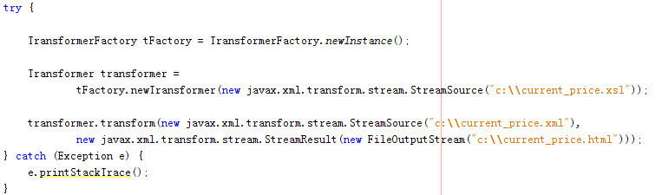
- Results

Prepare
1) Before running:”C://temp.txt” must be created for the reason talked above.
2) in C root
C://logs.xsl
C://current.xsl
C://temp.txt are necessary.

Validation
XSLT&XML validation:
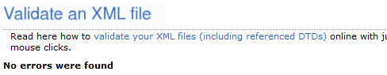

running
we can write code to main() like this for example:
In customer1
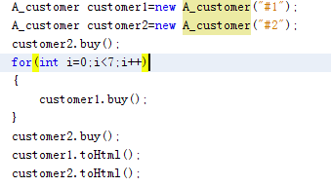
1) Test web service
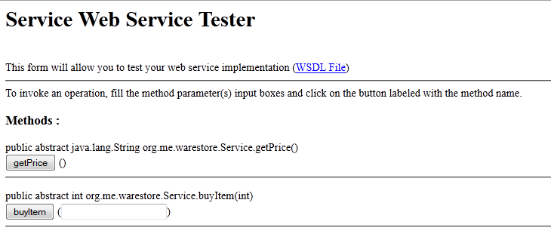
2) Running Client:
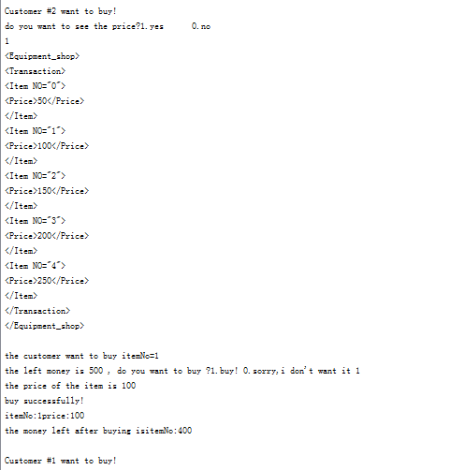
2)……….when it comes not afford to buy
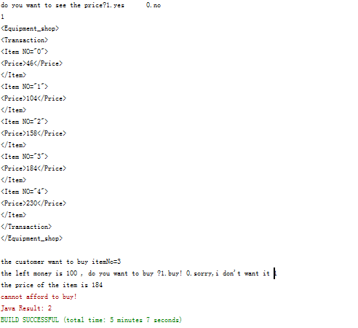
3)At this time. Running JAVA application Customer2
The price has been update in Customer1
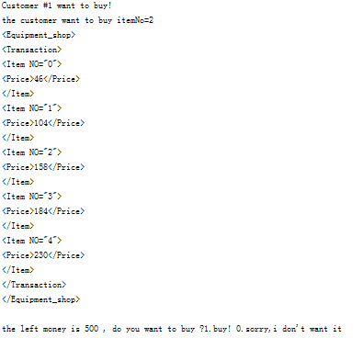
4)looking at C://logs.xml
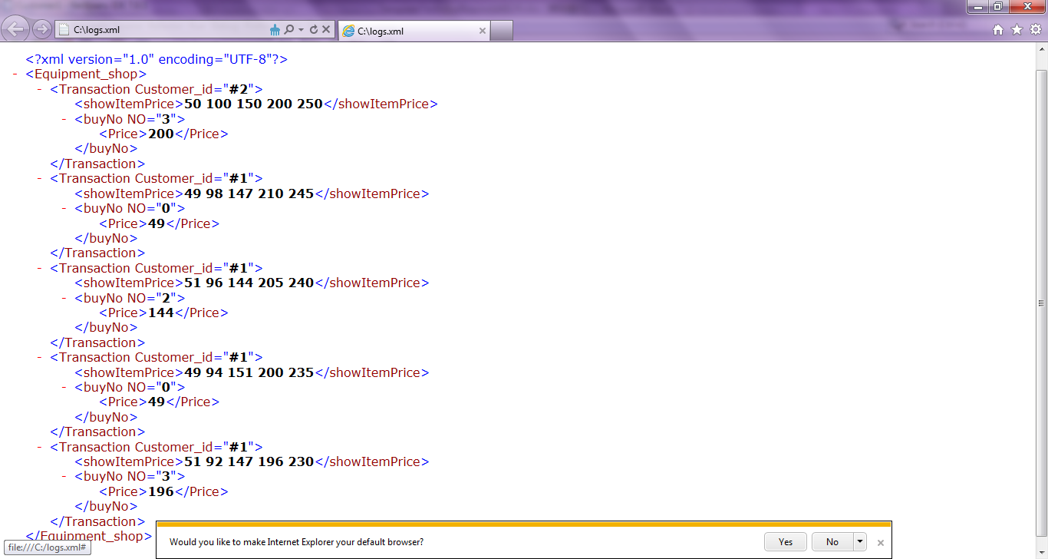
5)Running C://logs.html
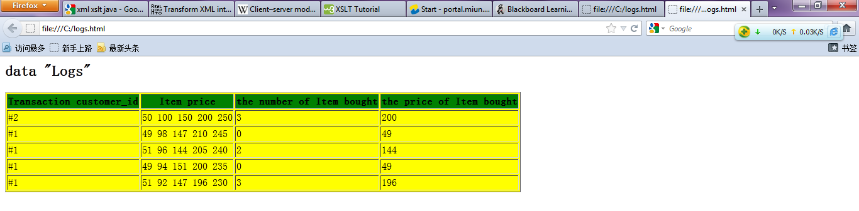
6)looking at C://current_price.xml
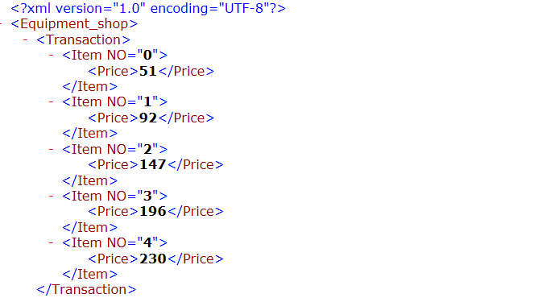
7)looking at C://current_price.html
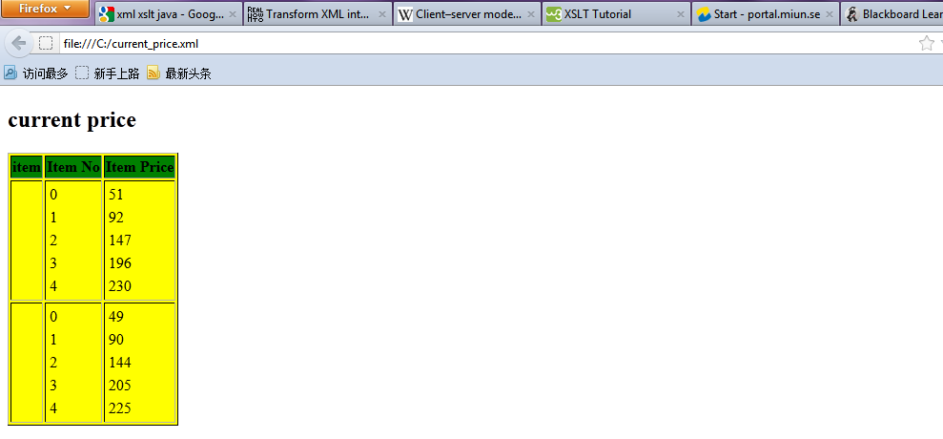
- Discussion

The advantage of the project
- The result is done as expected; all of the requirements are met.
- Two different JAVA application clients can share the same server and have access to get and update date.
- Transform XML to HTML using XSLT.
- The project is centred on user’s convenience and equipment reliability and high availability of the hardware.
- When error is occurred, the indicating information is different.
- The user can interact with the data returned from the web service.

The disadvantage of the project
- The user interface is simple but easy running.
- The project only meets the original needs, when compared to original group project; it is a little easy and only using in narrow range.
- In the project, Memory is used by “C://temp.txt”, waste of space

The improvement
- More function and web service operation should be designed, such as produce items.
- The code is not clear.
- Add error handling code to the client

Some other discussion
After you create the web service, you write three different web service clients that use the web service over a network, which is called "consuming" a web service. The three clients are a Java class in a Java SE application, a servlet, and a JSP page in a web application ^{[1]}.

References
- Oracle corporation, ”getting started with JAX-WS”,
http://netbeans.org/kb/docs/websvc/jax-ws.html
- Diane McDonald, ” Web Services Technologies Report”, JISC TSW Report: Web Services Technologies , TSW 03-04 May 2003 © JISC 2003
- W3school, “XML DOM tutorial”, http://www.w3schools.com/dom/default.asp, copyright 1999-2012
- H.M.Deitel, ” JAVA How to program,Sixth Edition”.www.phel.com.cn¨,publish 2005

